SALES ANALYSIS USING EXCEL

PROJECT REPORT



Submitted by

**Aryan Kumar**

Registration No. **12310657**

Programme and Section: **B.Tech, K23DW**

Course Code: **INT217**

Under the Guidance of

**Anchal Kaundal (29612)**

**Discipline of CSE/IT**

**Lovely School of Computer Science and Engineering**

**Lovely Professional University, Phagwara**

# DECLARATION

I, Aryan Kumar, student of Bachelors of Technology under CSE/IT Discipline at Lovely Professional University, Punjab, hereby declare that all the information furnished in this project report is based on my own intensive work and is genuine.

Name of the Student: Aryan Kumar

Registration No.: 12310657 Date: 12 April, 2025

# CERTIFICATE

This is to certify that **Aryan kumar** bearing Registration no. **12310657** has completed **INT217** project titled, **“Sales Analysis Dashboard Using Excel”** under my guidance and supervision. To the best of my knowledge, the present work is the result of his original development, effort, and study.

Name of the Supervisor :- **Anchal Kaundal**

# ACKNOWLEDGEMENT

I would like to express my sincere gratitude to my mentor, **Anchal Kaundal**, for his continuous support and invaluable guidance throughout the course of this project. His insights and encouragement have been instrumental in my learning and in the successful completion of this report.

I extend my heartfelt thanks to my friends and classmates for their motivation, feedback, and technical discussions, which enhanced the quality of my analysis. Special thanks to my family for their unwavering support, patience, and inspiration throughout the project duration.

# TABLE OF CONTENTS

|  |  |
| --- | --- |
| Introduction | 6 |
| Source of Dataset | 7 |
| Dataset Preprocessing | 8 |
| Analysis on Dataset  i. General Description  ii. Specific Requirements  iii. Analysis Results  iv. Visualization | 9 |
| Conclusion | 15 |
| Future Scope | 16 |
| References | 17 |

**Introduction**

This report presents a comprehensive sales analysis dashboard created using Microsoft Excel. The primary goal is to transform raw sales data into meaningful insights through visualizations, KPIs, and trend analysis, enabling better business decisions. The dashboard provides an overview of various sales dimensions, including monthly sales performance, product category contributions, region-wise sales, and customer segmentation.

This project demonstrates how Excel can serve as a powerful tool in business analytics, enabling data cleaning, dynamic dashboards, and real-time interaction through slicers and pivot charts. By the end of the project, stakeholders should be able to interpret trends, compare category performance, and identify areas for improvement.

**Source of Dataset**

The dataset used in this project is a simulated sales data file containing transactional details, including:

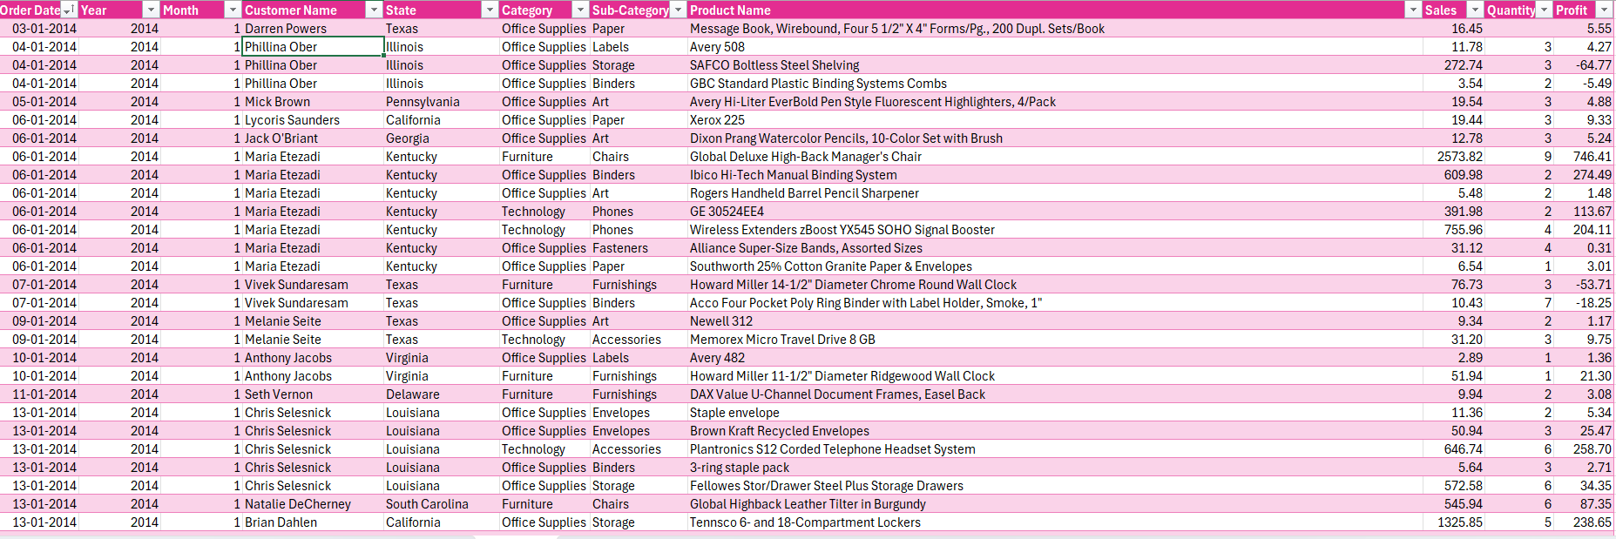

This dataset was processed in Microsoft Excel and reflects realistic sales patterns across different regions and categories. The dataset was sourced for academic purposes and structured in Excel format.

**Dataset Preprocessing**

Initial data preparation steps included:  
- Removing duplicate records  
- Formatting date columns correctly  
- Handling missing values in customer or region fields  
- Standardizing product category names

Excel features used for preprocessing:  
- Data Validation  
- IFERROR and ISBLANK functions  
- Conditional Formatting to identify anomalies  
- Filter tools for outlier detection

The cleaned dataset was then transformed into structured tables, making it suitable for PivotTables and chart creation.

**Analysis on Dataset**

i. General Description

The dashboard summarizes key metrics:  
- Monthly Sales Trends  
- Category-wise Contribution  
- Region-wise Performance  
- Top-Selling Products  
- Customer Segmentation by Sales Value

ii. Specific Requirements

Excel Tools and Functions used:  
- Pivot Tables for dynamic grouping  
- Slicers for interactivity by Category, Region, and Time Period  
- Formulas: SUMIFS, COUNTIFS, AVERAGEIFS  
- Charts: Line, Column, Bar, Pie, Donut

iii. Analysis Results

Key insights discovered:  
- The highest sales were recorded in Q4, especially in December.  
- Electronics and Furniture were the most profitable categories.  
- The East region outperformed other regions in total revenue.  
- A small group of loyal customers accounted for a large portion of revenue.  
- Some months experienced dips in sales, indicating possible seasonal factors or stock issues.

iv. Visualization

The dashboard includes:  
- Line Chart for Monthly Sales  
- Donut Chart for Category Contribution  
- Bar Graph for Region-wise Sales  
- Customer Segment Pie Chart  
- KPI Cards for Total Sales, Units Sold, and Average Order Value

**Raw Data Of Excel**

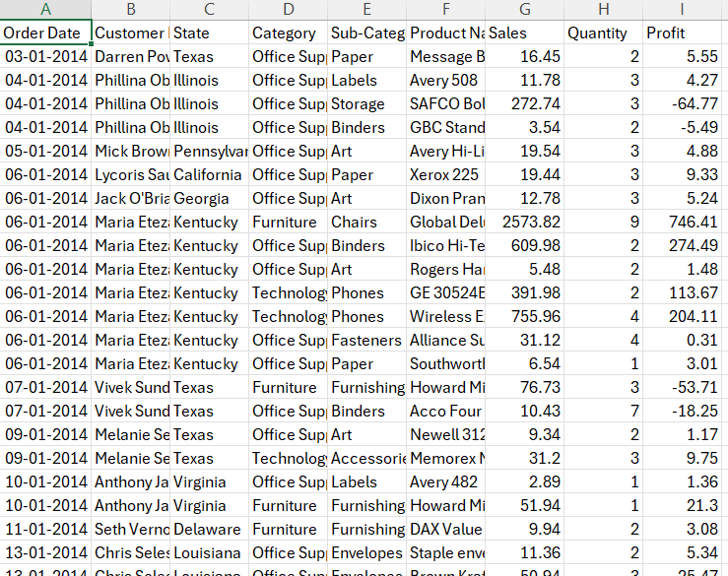

**After Data Preprocessing**



**Dashboard**

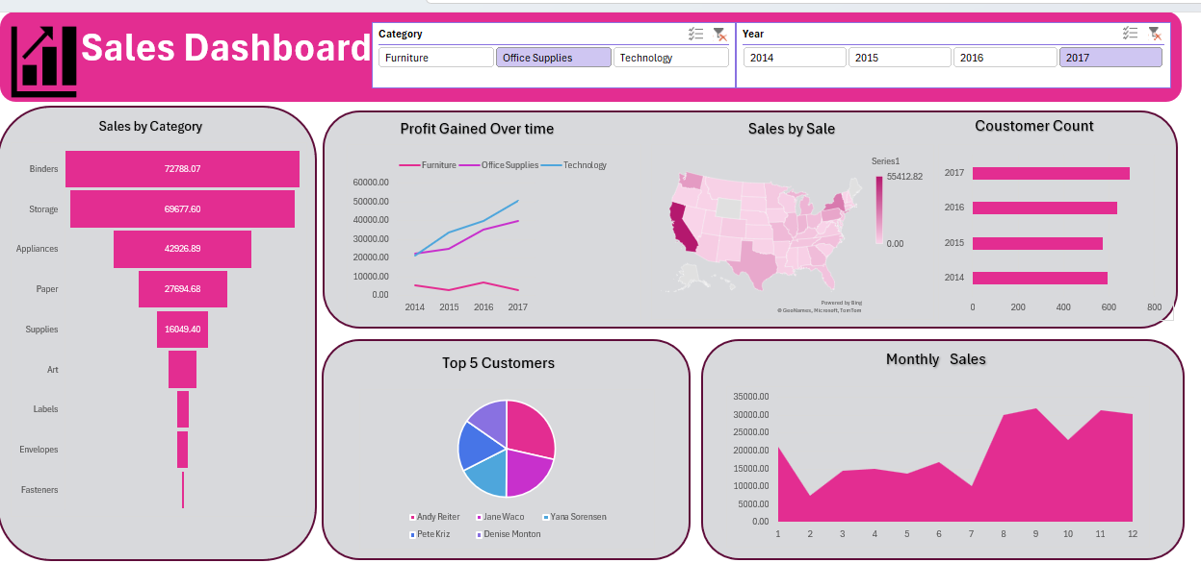

**Pivot Table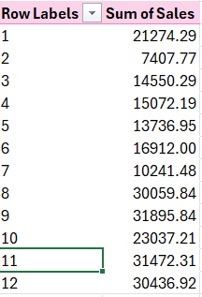**

**Conclusion**

The sales dashboard effectively converts raw transactional data into digestible business intelligence. The analysis reveals clear sales trends, identifies strong performing areas, and uncovers potential weaknesses. Excel has proven to be a robust platform for data analysis and visualization, even without the use of advanced tools like Power BI.

The project highlights how critical data-driven decision-making is for modern businesses and how tools like Excel remain relevant and powerful.

**LinkedIn**

https://www.linkedin.com/posts/princearora12_excel-salesdashboard-dataanalysis-activity-7316535617775882240-oJnU?utm_source=social_share_send&utm_medium=member_desktop_web&rcm=ACoAAEU91-0BKA4_GVLawO4Ayt-QMdTmghD-XN4

**Future Scope**

- Integration with Power BI or Tableau for more advanced analytics  
- Adding predictive sales modeling using Excel’s Forecast Sheet  
- Automating data import and refresh via Power Query  
- Expanding the dataset to include profit margins and customer demographics for deeper analysis  
- Embedding interactive charts into web dashboards

**References**

[1] Microsoft Support, "Create a PivotTable to Analyze Worksheet Data." Available: https://support.microsoft.com/en-us/office/create-a-pivottable-to-analyze-worksheetdata-a9a84538-bfe9-40a9-a8e9-f99134456576

[2] Microsoft Support, "Overview of Excel Functions by Category." https://support.microsoft.com/en-us/office/excel-functions-by-category-5f91f4e9-7b42-46d2-9bd1-63f26a86c0eb

[3] Microsoft Support, "Create a Chart from Start to Finish." https://support.microsoft.com/en-us/office/create-a-chart-from-start-to-finish-e81dff3f-0bda-4111-9f33-3e1c3f7c3b9e

[4] Microsoft Support, "Use Slicers to Filter Data in PivotTables." https://support.microsoft.com/en-us/office/use-slicers-to-filter-data-in-pivottables-0c6b8faa-96a7-4e44-ae46-73e8a36f0c57